Aim
To design and implement an Artificial Neural Network (ANN) using TensorFlow/Keras for classification on a real-world dataset and evaluate its performance.
Theory
An Artificial Neural Network (ANN) is a machine learning model inspired by the human brain. It consists of layers of interconnected neurons.
Key Components:
- Input Layer: Takes input features
- Hidden Layers: Perform computations using weights and activation functions
- Output Layer: Produces final prediction
Important Concepts:
- Weights & Biases: Parameters adjusted during training
- Activation Functions:
  - ReLU (Rectified Linear Unit)
  - Sigmoid
  - Softmax
- Loss Function: Measures error (e.g., binary_crossentropy)
- Optimizer: Updates weights (e.g., Adam)
- Backpropagation: Learning algorithm to minimize loss
Advantages:
- Handles complex non-linear relationships
- Widely used in classification, prediction, image recognition

Procedure
- Import required libraries
- Load dataset
- Preprocess data (scaling, encoding)
- Split dataset into training & testing
- Build ANN model
- Compile model
- Train the model
- Evaluate performance
- Make predictions
CODE:
# Step 1: Import Libraries
import numpy as np
import pandas as pd
from tensorflow.keras.models import Sequential
from tensorflow.keras.layers import Dense
from sklearn.model_selection import train_test_split
from sklearn.preprocessing import StandardScaler

# Step 2: Load Dataset
dataset = pd.read_csv("diabetics.csv", header=None)

# Step 3: Split into input and output
X = dataset.iloc[:, :-1].values
y = dataset.iloc[:, -1].values

# Step 4: Train-Test Split
X_train, X_test, y_train, y_test = train_test_split(X, y, test_size=0.2)

# Step 5: Feature Scaling
sc = StandardScaler()
X_train = sc.fit_transform(X_train)
X_test = sc.transform(X_test)

# Step 6: Build ANN Model
model = Sequential()

# Input + Hidden Layer 1
model.add(Dense(units=8, activation='relu', input_dim=X.shape[1]))

# Hidden Layer 2
model.add(Dense(units=8, activation='relu'))

# Output Layer
model.add(Dense(units=1, activation='sigmoid'))

# Step 7: Compile Model
model.compile(optimizer='adam', loss='binary_crossentropy', metrics=['accuracy'])

# Step 8: Train Model
model.fit(X_train, y_train, epochs=100, batch_size=10)

# Step 9: Evaluate Model
loss, accuracy = model.evaluate(X_test, y_test)
print("Accuracy:", accuracy)

# Step 10: Prediction
y_pred = model.predict(X_test)
y_pred = (y_pred > 0.5)

print(y_pred[:10])

OUTPUT:

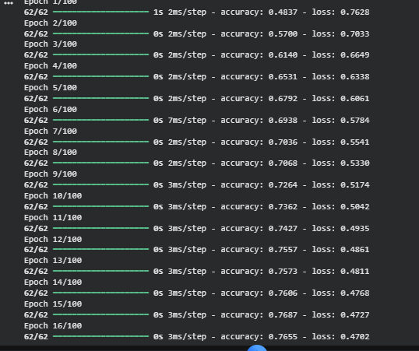

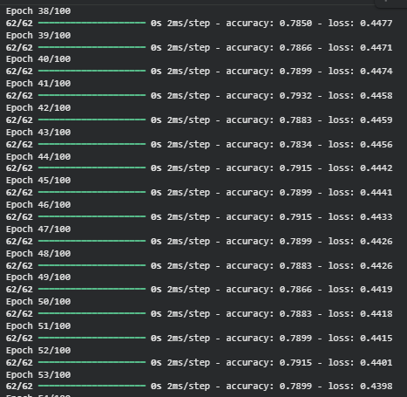
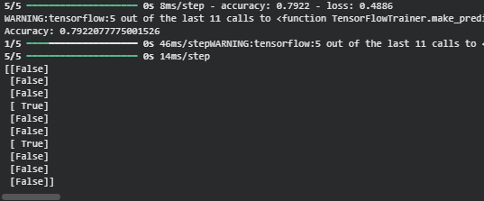
- Model accuracy will be around 70%–80% depending on training
- Predictions will be in binary form (0 or 1)

CONCLUSION:
An Artificial Neural Network was successfully implemented using TensorFlow/Keras. The model was trained on a real-world dataset and achieved good classification accuracy. This experiment demonstrates how ANNs can effectively learn patterns and make predictions in classification problems. ANN models are powerful tools widely used in real-world applications such as healthcare, finance, and image recognition.

